**31thjan ’21 DECISION TREE CLASSIFICATION MODEL**

**NAME:**SARIKA M

**AIM:**

To build a Decision Tree model for prediction of car quality given other attributes about the car.

**VARIABLES USED :**

buying - buying price

maintaince - price for the maintance

doors - no.of.doors

persons - no.of. persons

lug_boot - the size of luggageboot

safety - estimated safety of the car

class - class distribution ('unacc', 'acc', 'vgood', 'good')

**MODEL:**

**IMPORTING THE LIBRARIES:**

import numpy as np

import pandas as pd

import matplotlib.pyplot as plt

import seaborn as sns

**IMPORTING DATASET:**

data=pd.read_csv("D://datasets//car_evaluation.csv")

data.head(5)

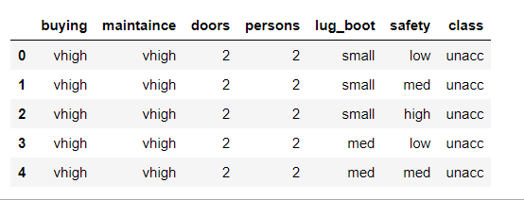

**DATA ANALYSIS:**

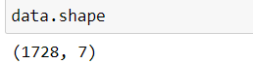

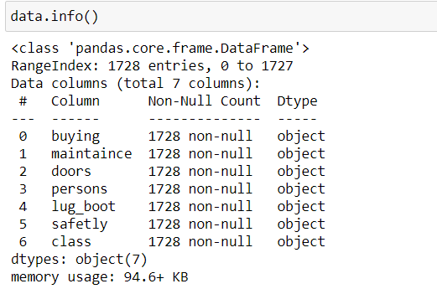

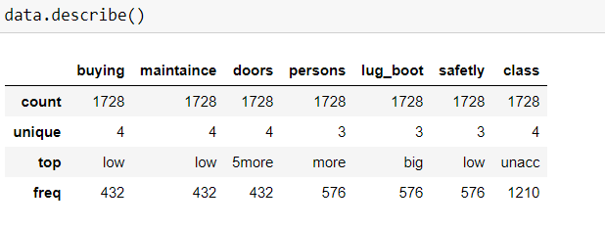

**DATA WRANGLING:**

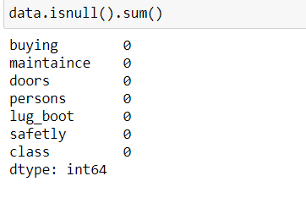

data['buying'],_ = pd.factorize(data['buying'])

data['maintaince'],_ = pd.factorize(data['maintaince'])

data['doors'],_ = pd.factorize(data['doors'])

data['persons'],_ = pd.factorize(data['persons'])

data['lug_boot'],_ = pd.factorize(data['lug_boot'])

data['safety'],_ = pd.factorize(data['safety'])

data.head()

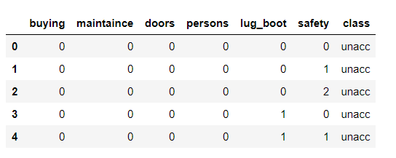

data['class'],class_names = pd.factorize(data['class'])

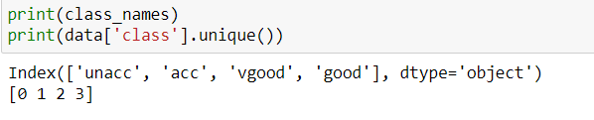

**DATA VISUALIZATION:**

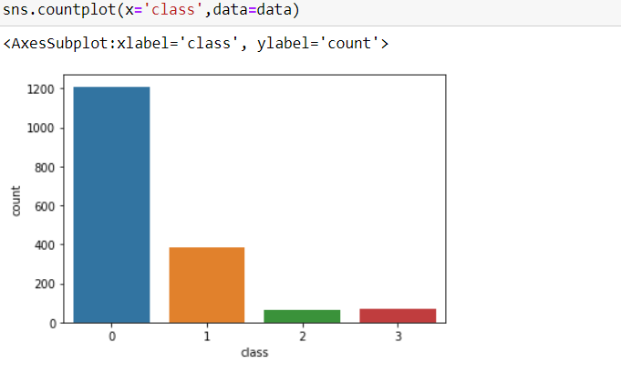

From the above plot we can interpret that class 0 (unacc) has more number than any other class.

sns.pairplot(data)

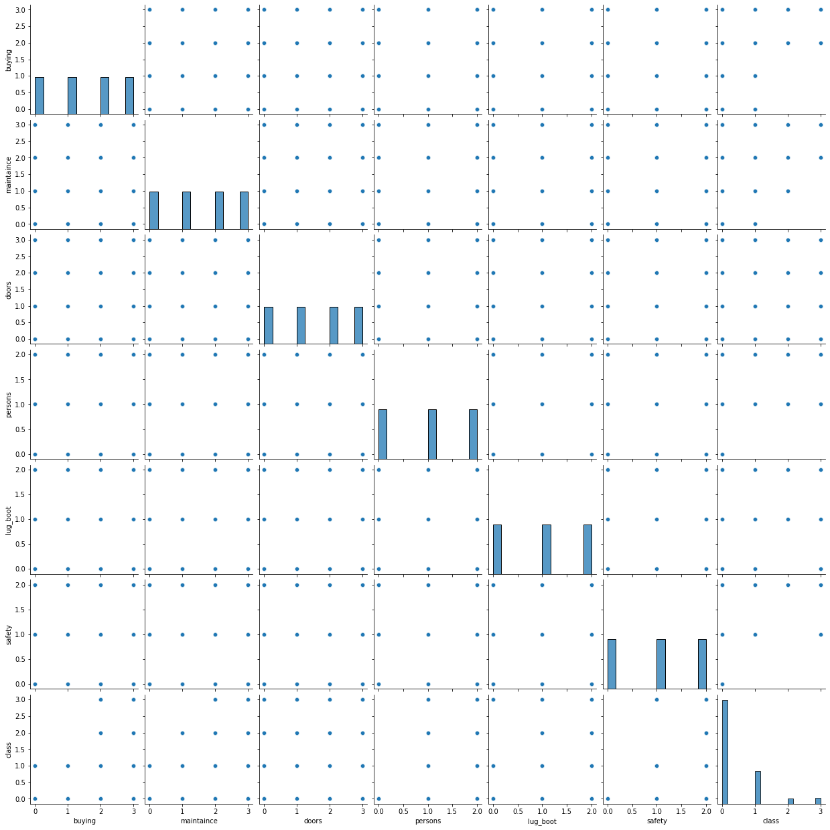

**DATA PREPARATION:**



**LIBRARIES NEEDED FOR DECISION TREE CLASSIFIER**

from sklearn.model_selection import train_test_split

from sklearn.tree import DecisionTreeClassifier

from sklearn import metrics

from sklearn.metrics import classification_report, confusion_matrix

from sklearn import tree

**TEST-TRAIN SPLIT:**



**MODEL:**

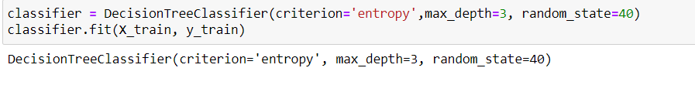

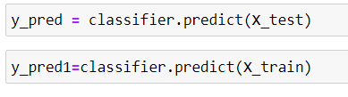

**CLASSIFICATION METRICS:**

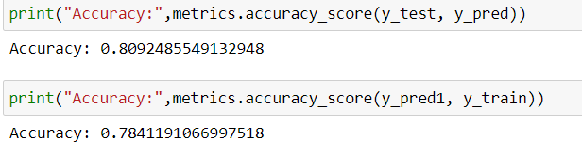

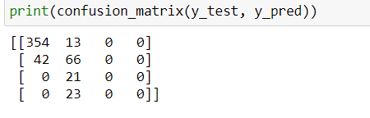

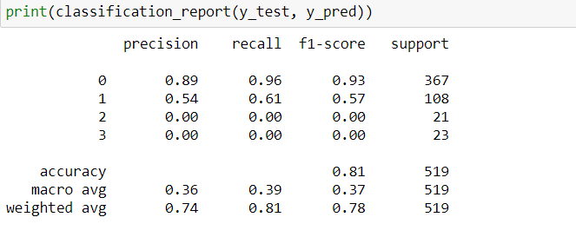

**TREE VISUALIZATION:**



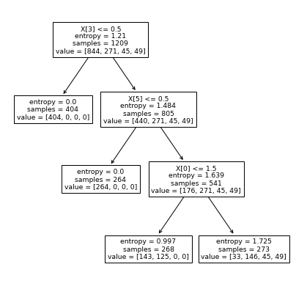

**PREDICTIONS:**

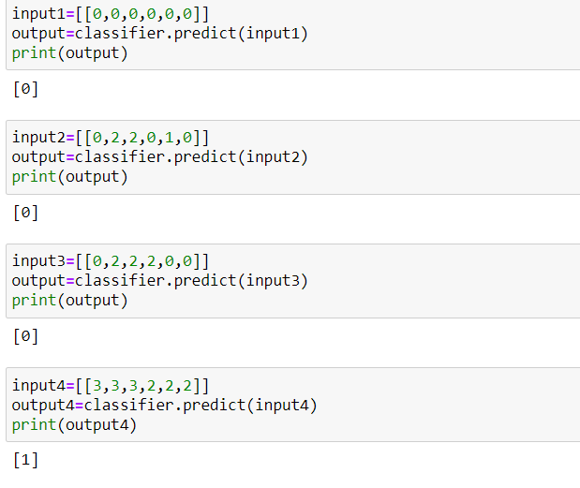

**ANALYSIS:**

* Accuracy of model came out as 80.9%
* The accuracy of test data and train data looks close . so It doesn’toverfit.
* Accuracy of confusion matrix came as 80%.